**ACE — Software Center**

This guide will help you install and configure the new, and reworked version of the **Staff LogOff Activity** tool. It works on both Windows and macOS platforms. The guide is divided into two sections: one for Windows users and one for macOS users. Follow the steps in the section that matches the targeted operating system

Staff LogOff Activity

The Complete configuration guide.

# Configuration for **Windows**

For the configuration of SLA on Windows, you will be provided with an independent **.zip** file, containing the necessary binaries, libraries, along with the executable file. The executable is capable of self-registering itself. Make sure to **uninstall** the previous version before proceeding.

## Placeholder image

## Step 01 — Placement

Navigate to **C:\** Drive in the targeted system, and place the provided **.zip** file there. Extract the content of the **.zip** file at the same location.

### Note:

Make sure to login as the authorized (admin) user, for required privileges for all the required operations.

## 

## 

## Step 02 — Execution

Execute the **SLA-Remake.exe** and it will auto-register for startup. Restart the system afterwards.

# Configuration for **macOS**

For the configuration of SLA on macOS, you will be provided with a **.zip** file, containing the necessary binaries, libraries, along with the executable file. The executable requires specific accessibility features, which have to be manually configured for macOS. Make sure to **uninstall** the previous version before proceeding, and **reboot** the system after the configuration process.

## 



## Step 01 — Placement

Navigate to User’s folder (folder with the Username) in the targeted system. Now extract the content of the **.zip** file at that directory.

### Note:

Make sure to not login as the admin user, for proper configurations for the targeted system.

## 

## 

## Step 02 — Granting the Privacy-Access

* Open a new **Terminal**, and execute the following command to grant execution privilege:

|  |
| --- |
| chmod +x 'SLA-Remake/SLA-Remake' |

* Navigate to: **System Preferences** > **Security & Privacy** > **Privacy**
* Unlock the Settings by clicking the Lock icon below, and giving the password.
* Grant the following permissions to the **SLA-Remake**, and **Terminal** (where possible):
  + **Accessibility**
  + **Full Disk Access**

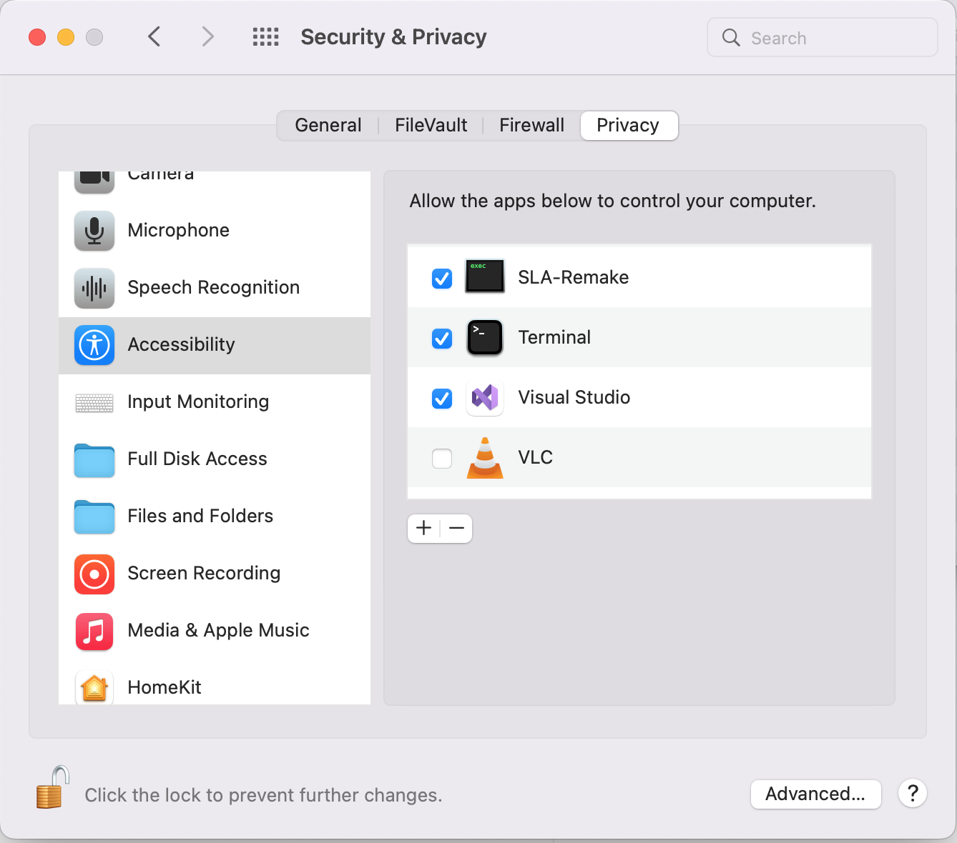

### 

### Note:

If the name of the executable (**SLA-Remake**) doesn’t appear, click on the **+** icon below, and add the executable, by navigating to the installation directory of SLA, and selecting the **SLA-Remake**.

## Step 03 — Granting the Security-Access

macOS has a Security feature called **Gatekeeper** which restricts the apps installed from the sources other than AppStore. Since the SLA is not made available there, the Gatekeeper will recognize the SLA as an unidentified software product, and won’t let it execute normally. To cope with the situation, we have curated two sets of solutions.

#### Solution 01 — Manually Granting the Access

* Execute the **SLA-Remake** by right-clicking, and selecting **Open**.
* Most likely, a Dialog will appear reporting an Accessibility issue.

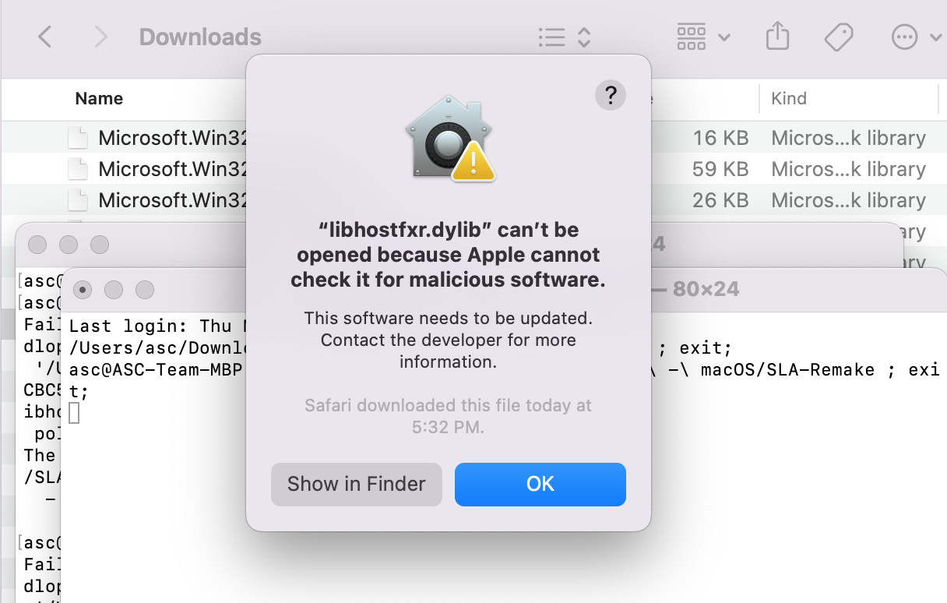

* Click **OK**, close **Terminal** and Navigate to: **System Preferences** > **Security & Privacy**
* Click on the little **Lock** icon below, to unlock the Settings.
* In the **General** tab, there will be the Report, with the button of **Allow Anyway**

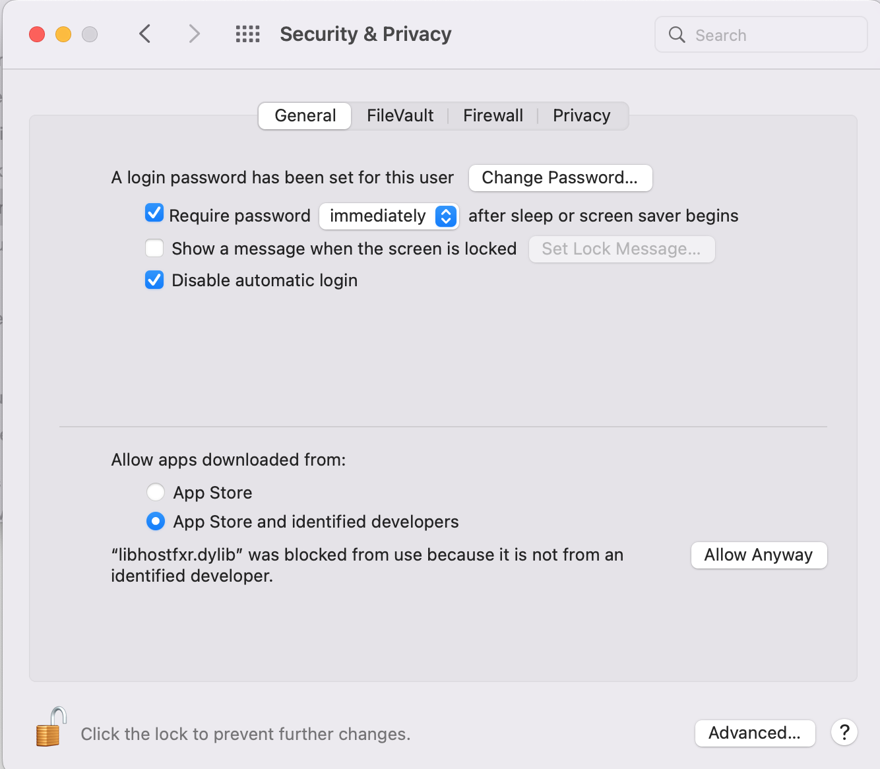

* Click **Allow Anyway** and again try to execute the **SLA-Remake** from the installation directory, by right-clicking and selecting **Open**.
* Similar Dialog box will appear again, and now with the option to **Open**. Select **Open**.
* If any Dialog box appears again, Repeat the above process, until the SLA starts.
* Lastly, wait for at-least **30s**, and be sure to not have any pending accessibility grant (i.e. no **Allow Anyway** button) in the **General** tab of **System Preferences** > **Privacy & Security**

#### Solution 02 — Disabling the Gatekeeper

* Open a new Terminal and execute the following command to disable the Gatekeeper

|  |
| --- |
| sudo spctl --master-disable |

* Now execute the **SLA-Remake** by Right-Click then **Open**, and the SLA will run with ease.

# Process of **Uninstallation**

The SLA-Remake is entirely self-contained that does not require any external dependencies or leave any traces on the target system, whether it is Windows or macOS. This simplifies the installation and uninstallation process to a great extent.

### Windows

* Stop the **SLA-Remake.exe** from the Task Manager, if the SLA-Remake is already running in the targeted system (or in-case of older/legacy SLA, run the uninstallation script).
* Then, just delete the Installation directory (**SLA Remake**), from **C:/** Drive (as suggested in the installation process), and SLA will be completely uninstalled.

### macOS

* In macOS, run the following command to cleanup the previous startup registration:

|  |
| --- |
| rm ~/Library/LaunchAgents/SLA-Remake.plist |

* **Force-Restart** the system to stop the running instance of SLA, by long-pressing the power button, until the system gets shut down, then boot the system again.
* Then, similar to the case of Windows, delete the installation directory of SLA, from User’s folder (as suggested in the installation process). **Alternatively**, you can use:

|  |
| --- |
| rm 'SLA-Remake' |